PROJECT TITLE

by

Student Name (Student ID)
Student Name (Student ID)
Student Name (Student ID)

Report on

EEE 4700 (Project and Thesis)



Department of Electrical and Electronic Engineering
Islamic University of Technology (IUT)
Gazipur, Bangladesh

January 2024
THESIS TITLE

Approved by:
--------------------------------------------
Dr. XXX
Supervisor and [Associate/Assistant] Professor,
Department of Electrical and Electronic Engineering, Islamic University of Technology (IUT), Boardbazar, Gazipur-1704.

Date: ……

Table of Contents
List of Tables 3
List of Figures 4
List of Acronyms 5
1 Introduction 6
1.1 Basic Functionalities of 6
1.2 Different Aspects ….. 6
1.3 Background and Motivation 6
2 Overview of …. 7
2.1 Introduction 7
2.2 Network Architecture 7
2.2.1 The …. 8
2.2.2 The …. 8
3 Demonstration of Outcome Based Education (OBE) 9
3.1 Introduction 9
3.2 Course Outcomes (COs) Addressed 9
3.3 Aspects of Program Outcomes (POs) Addressed 10
3.4 Knowledge Profiles (K3 – K8) Addressed 11
3.5 Use of Complex Engineering Problems 11
3.6 Socio-Cultural, Environmental, And Ethical Impact 11
3.7 Attributes of Ranges of Complex Engineering Problem Solving (P1 – P7) Addressed 12
3.8 Attributes of Ranges of Complex Engineering Activities (A1 – A5) Addressed 13
4 References 14

List of Tables

Table 2.1 Evolution of 3GPP technologies 7

List of Figures

Figure 2.1: Network architecture 7

List of Acronyms

AM | Acknowledged Mode
APN | Access Point Name Packet Data Network

Chapter 1

Introduction

The ……
The major …….

Basic Functionalities of
The operation…..

Different Aspects …..
The research delves into ..

Background and Motivation
The research presented in this dissertation aims at…

Chapter 2

Overview of ….

In order to meet the continued…

Introduction
The industry witnessed …

Table 2.1 Evolution of 3GPP technologies
Generation | Technologies | Service | Theoretical Data Rate | Multiplexing Technique
2G | GSM | Voice | 9.6-19.2 kbps | FDMA/TDMA
2.5G | GPRS | Data | 44-171.2 kbps | FDMA/TDMA
2.75G | EDGE | Data | 384 kbps | FDMA/TDMA

Network Architecture
The evolved
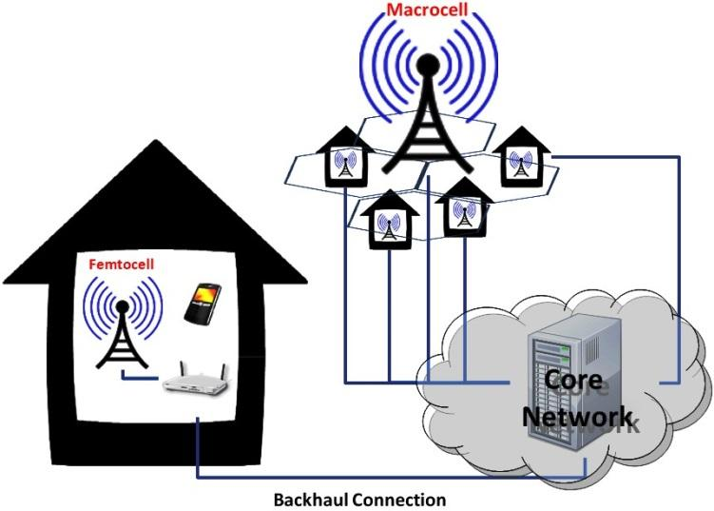
Figure 2.1: Network architecture

The ….
The ….

The ….
The ……

Chapter 3

Demonstration of Outcome Based Education (OBE)

The ..

Introduction
The industry witnessed …

Course Outcomes (COs) Addressed
The following table shows the COs addressed in EEE 4700 for Project and Thesis.

COs | CO Statement | POs | Put Tick ( √ )
CO1 | Apply knowledge of electrical and electronic engineering to the solution of complex engineering problems. | PO1
CO2 | Identify a contemporary real life problem related to electrical and electronic engineering by reviewing and analyzing existing research works. | PO2
CO3 | Determine functional requirements of the problem considering feasibility and efficiency through analysis and synthesis of information. | PO4
CO4 | Select a suitable solution and determine its method considering professional ethics, codes and standards. | PO8
CO5 | Adopt modern engineering resources and tools for the solution of the problem. | PO5
CO6 | Prepare management plan and budgetary implications for the solution of the problem. | PO11
CO7 | Analyze the impact of the proposed solution on health, safety, culture and society. | PO6
CO8 | Analyze the impact of the proposed solution on environment and sustainability. | PO7
CO9 | Develop a viable solution considering health, safety, cultural, societal and environmental aspects. | PO3
CO10 | Work effectively as an individual and as a team member for the accomplishment of the solution. | PO9
CO11 | Prepare various technical reports, design documentation, and deliver effective presentations for demonstration of the solution. | PO10
CO12 | Recognize the need for continuing education and participation in professional societies and meetings. | PO12

Aspects of Program Outcomes (POs) Addressed

The following table shows the aspects addressed for certain Program Outcomes (POs) addressed in EEE 4700 for Project and Thesis.

 | Statement | Different Aspects | Put Tick  ( √ )
PO3 | Design/development of solutions: Design solutions for complex electrical and electronic engineering problems and design systems, components or processes that meet specified needs with appropriate consideration for public health and safety, cultural, societal, and environmental considerations. | Public health
PO3 |  | Safety
PO3 |  | Cultural
PO3 |  | Societal
PO3 |  | Environmental
PO4 | Investigation: Conduct investigations of complex electrical and electronic engineering problems using research-based knowledge and research methods including design of experiments, analysis and interpretation of data, and synthesis of information to provide valid conclusions. | Design of experiments
PO4 |  | Analysis and interpretation of data
PO4 |  | Synthesis of information
PO6 | The engineer and society: Apply reasoning informed by contextual knowledge to assess societal, health, safety, legal and cultural issues and the consequent responsibilities relevant to professional engineering practice and solutions to complex electrical and electronic engineering problems. | Societal
PO6 |  | Health
PO6 |  | Safety
PO6 |  | Legal
PO6 |  | Cultural
PO7 | Environment and sustainability: Understand and evaluate the sustainability and impact of professional engineering work in the solution of complex electrical and electronic engineering problems in societal and environmental contexts. | Societal
PO7 |  | Environmental
PO8 | Ethics: Apply ethical principles embedded with religious values, professional ethics and responsibilities, and norms of electrical and electronic engineering practice. | Religious values
PO8 |  | Professional ethics and responsibilities
PO8 |  | Norms
PO10 | Communication: Communicate effectively on complex engineering activities with the engineering community and with society at large, such as being able to comprehend and write effective reports and design documentation, make effective presentations, and give and receive clear instructions. | Comprehend and write effective reports
PO10 |  | Design documentation
PO10 |  | Make effective presentations
PO10 |  | Give and receive clear instructions
PO11 | Project management and finance: Demonstrate knowledge and understanding of engineering management principles and economic decision-making and apply these to one’s own work, as a member and leader in a team, to manage projects and in multidisciplinary environments. | Engineering management principles
PO11 |  | Economic decision-making
PO11 |  | Manage projects
PO11 |  | Multidisciplinary environments

Knowledge Profiles (K3 – K8) Addressed

The following table shows the Knowledge Profiles (K3 – K8) addressed in EEE 4700 for Project and Thesis.

K | Knowledge Profile (Attribute) | Put Tick  ( √ )
K3 | A systematic, theory-based formulation of engineering fundamentals required in the engineering discipline
K4 | Engineering specialist knowledge that provides theoretical frameworks and bodies of knowledge for the accepted practice areas in the engineering discipline; much is at the forefront of the discipline
K5 | Knowledge that supports engineering design in a practice area
K6 | Knowledge of engineering practice (technology) in the practice areas in the engineering discipline
K7 | Comprehension of the role of engineering in society and identified issues in engineering practice in the discipline: ethics and the engineer’s professional responsibility to public safety; the impacts of engineering activity; economic, social, cultural, environmental and sustainability
K8 | Engagement with selected knowledge in the research literature of the discipline

The following table explains or justifies how the Knowledge Profiles (K3 – K8) have been addressed in EEE 4700/4800 (Project and Thesis).

K | Explanation/Justification
K3
K4
K5
K6
K7
K8

Use of Complex Engineering Problems

The ……..

Socio-Cultural, Environmental, And Ethical Impact
The ……..

Attributes of Ranges of Complex Engineering Problem Solving (P1 – P7) Addressed
The following table shows the attributes of ranges of Complex Engineering Problem Solving (P1 – P7) addressed in EEE 4700 for Project and Thesis.

P | Range of Complex Engineering Problem Solving | Put Tick  ( √ )
Attribute | Complex Engineering Problems have characteristic P1 and some or all of P2 to P7: | Put Tick  ( √ )
Depth of knowledge required | P1: Cannot be resolved without in-depth engineering knowledge at the level of one or more of K3, K4, K5, K6 or K8 which allows a fundamentals-based, first principles analytical approach
Range of conflicting requirements | P2: Involve wide-ranging or conflicting technical, engineering and other issues
Depth of analysis required | P3: Have no obvious solution and require abstract thinking, originality in analysis to formulate suitable models
Familiarity of issues | P4: Involve infrequently encountered issues
Extent of applicable codes | P5: Are outside problems encompassed by standards and codes of practice for professional engineering
Extent of stakeholder involvement and conflicting requirements | P6: Involve diverse groups of stakeholders with widely varying needs
Interdependence | P7: Are high level problems including many component parts or sub-problems

The following table explains or justifies how the attributes of ranges of Complex Engineering Problem Solving (P1 – P7) have been addressed in EEE 4700/4800 (Project and Thesis).

P | Explanation/Justification
P1
P2
P3
P4
P5
P6
P7

Attributes of Ranges of Complex Engineering Activities (A1 – A5) Addressed
The following table shows the attributes of ranges of Complex Engineering Activities (A1 – A5) addressed in EEE 4700 for Project and Thesis.

A | Range of Complex Engineering Activities | Put Tick  ( √ )
Attribute | Complex activities means (engineering) activities or projects that have some or all of the following characteristics: | Put Tick  ( √ )
Range of resources | A1: Involve the use of diverse resources (and for this purpose resources include people, money, equipment, materials, information and technologies)
Level of interaction | A2: Require resolution of significant problems arising from interactions between wide-ranging or conflicting technical, engineering or other issues
Innovation | A3: Involve creative use of engineering principles and research-based knowledge in novel ways
Consequences for society and the environment | A4: Have significant consequences in a range of contexts, characterized by difficulty of prediction and mitigation
Familiarity | A5: Can extend beyond previous experiences by applying principles-based approaches

The following table explains or justifies how the attributes of ranges of Complex Engineering Activities (A1 – A5) have been addressed in EEE 4700/4800 (Project and Thesis).

A | Explanation/Justification
A1
A2
A3
A4
A5

References

- Marwat, Safdar Nawaz Khan, et al. "Congestion-aware handover in LTE systems for load balancing in transport network," ETRI Journal, vol. 3, no. 1, pp 761-771, 2014.
- Available: http://www.3glteinfo.com/lte-rlc-arq-procedure/ [Accessed 2024]

